Republic Democratic Popular Of Algeria
Ministry Of Transport
E T F I M Mostaganem

Long Term Training

Section : Patron Of The Coast Navigation (P N C)
Module: English
Teacher: Mrs Douar Rym

Maritime English

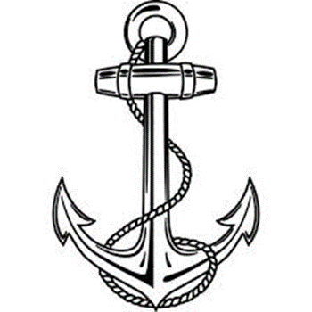
Lesson One:
The ship

1-Introduction To Maritime English
2-Definition Of a Ship
3-Main Parts of a Ship
4-Types of Merchant Ships

*Maritime English Definition:
Maritime English is an umbrella term which refers to the English language used by seafarers both at sea and in port and by individuals working in the shipping and shipbuilding .
Maritime English is very important for seafarers to communicate efficaciously when onboard a vessel .

*Definition Of a Ship:
A ship is a large vehicle used to travel on water it is bigger than a boat , most are cargo ships which carry most of the world’s international trade.

*Main Parts Of Ship

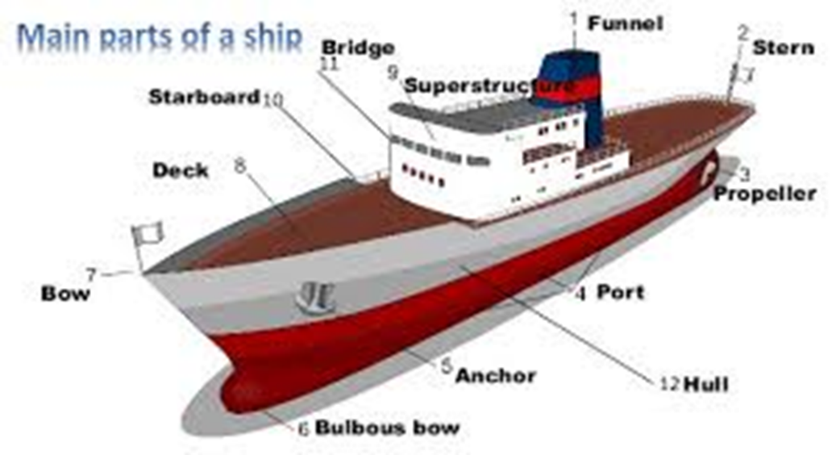

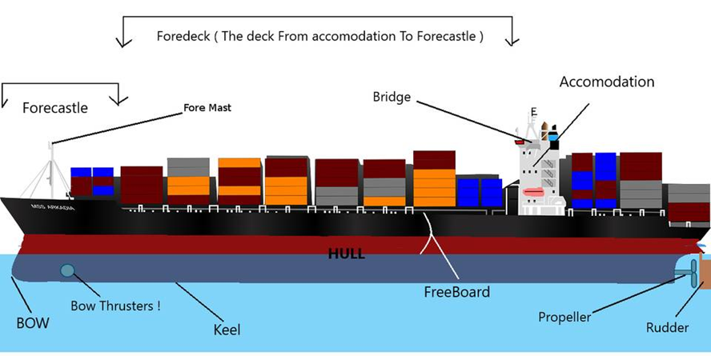

*Types of Merchant Ships:
Ships are mainly classified into the following types:
1. Container Ships;
2. Bulk Carrier;
3. Tanker Ships;
4. Roll-on Roll-Off Ships Passenger Ships;
5. Passenger Ships;
6. Offshore Ships;
7. Fishing Ships;
8. Tugs;
9. Pilot boat.

1. Container Ships:
As the name suggests, a vessel structured specifically to hold huge quantities of cargo compacted in different types of containers is referred to as a container vessel (ship).

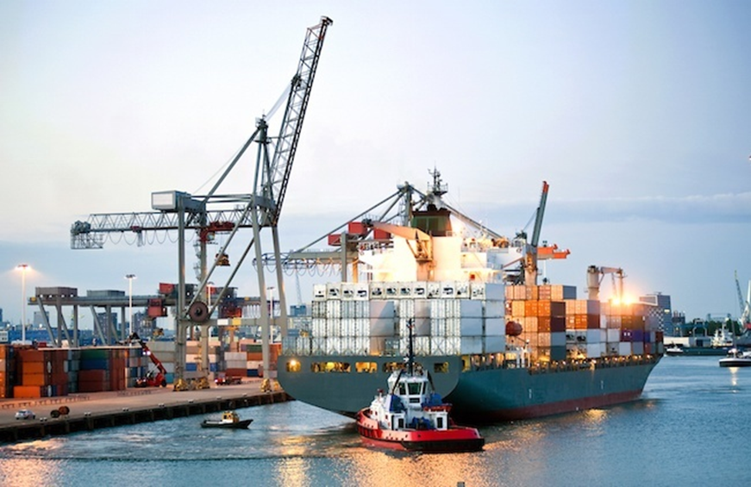

2. Bulk Carrier Ships
Bulk carriers are a type of ship which transports cargoes (generally dry cargo) in bulk quantities. The cargo transported in such ships is loose cargo i.e. without any specific packaging to it and generally contains items like food grains, ores and coals and even cement.
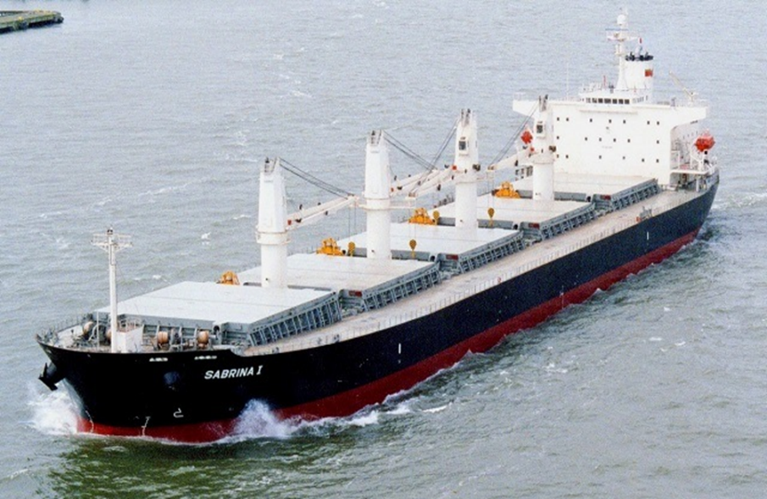

3. Tanker Ships
Tanker ships are specialised vessels for carrying a large amount of liquid cargo. Tankers are further sub-divided into different types on the basis of the cargo they carry.
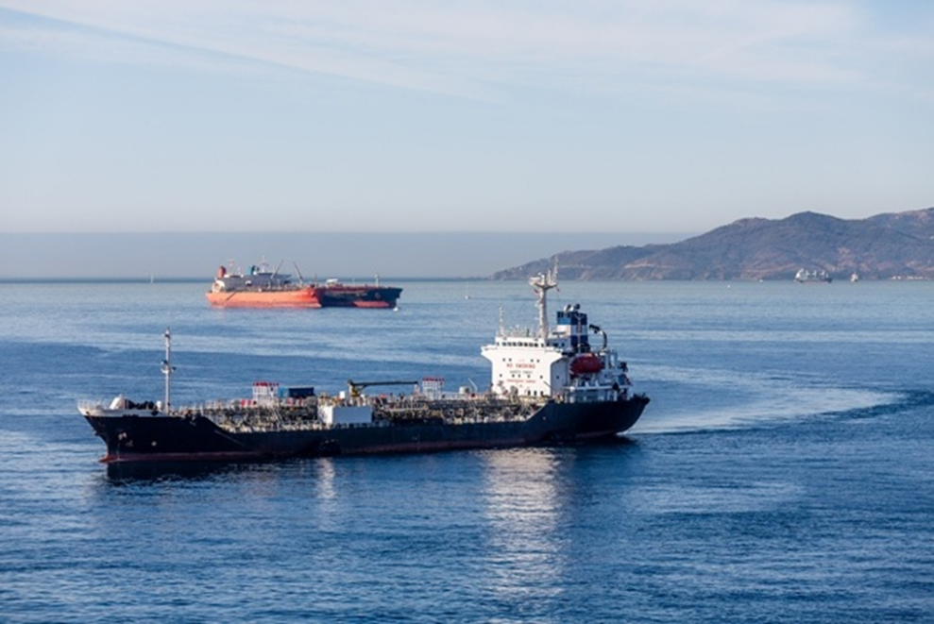

The main types of tankers are:
-Oil Tankers: Oil tankers mainly carry crude oil and its by-products.
-Liquefied Gas Carriers: A gas carrier (or gas tanker) is a ship designed to transport LPG, LNG or liquefied chemical gases in bulk.
-Chemical and Product Carriers: A chemical tanker is a type of tanker ship designed to transport chemicals and different liquid products in bulk

4. Roll-on Roll-Off Ships
Ro-Ro is an acronym for Roll-on/roll-off. Roll-on/roll-off ships are vessels that are used to carry wheeled cargo.

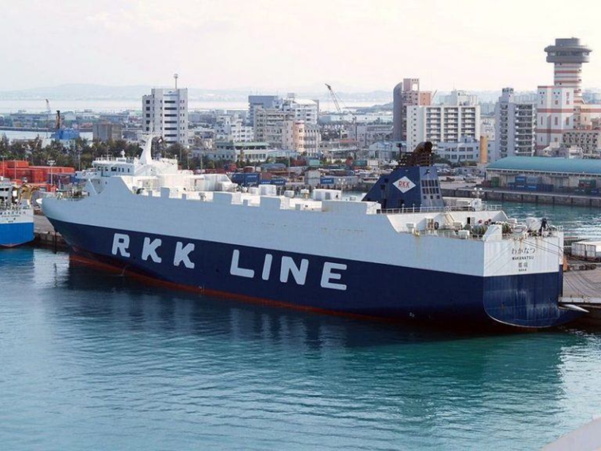

5. Passenger Ships
Passenger ships, as the name suggests, are mainly used for transiting passengers.

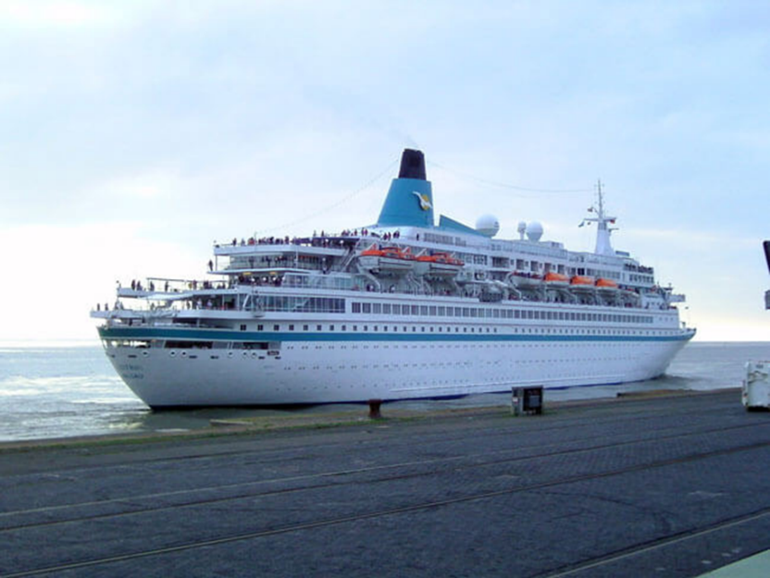

6. Offshore Vessels
Offshore vessels mainly help in oil exploration and construction jobs at sea. Offshore vessels are of several types.
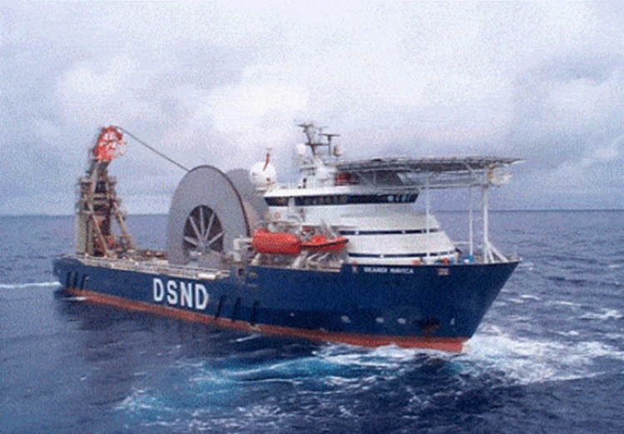

7. Fishing Vessels
Ships or boats used for recreational or commercial fishing at sea are called fishing vessels.
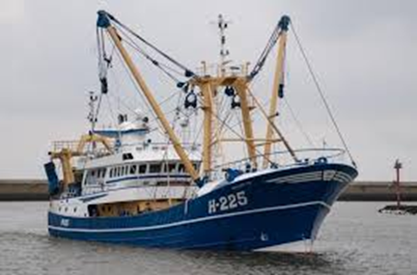

8. Tugs: A tug (tugboat) is a boat or ship that manoeuvres vessels by pushing or towing them.
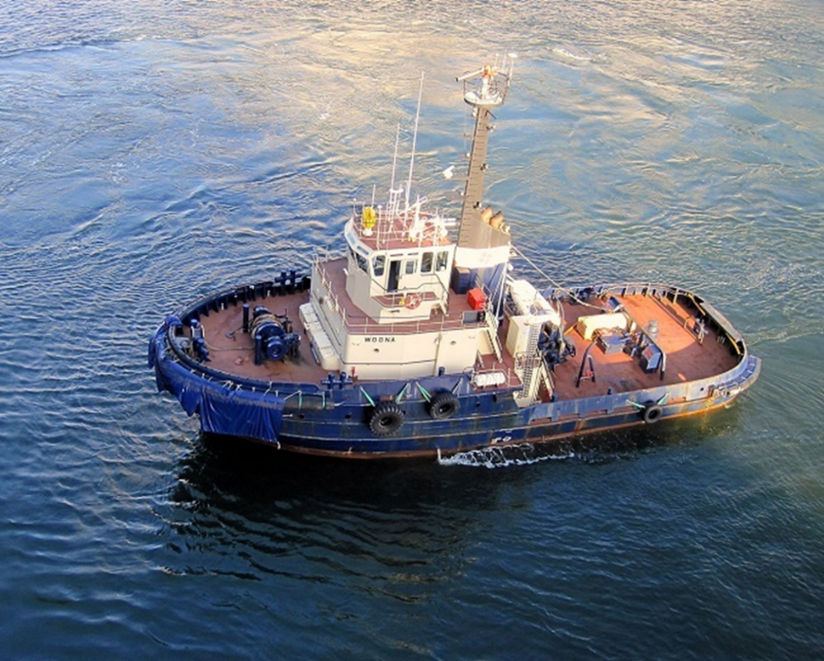

9. Pilot boat.
A pilot boat is a type of boat used to transport maritime pilots between land and the inbound or outbound ships that they are piloting.

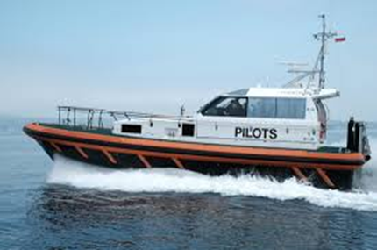

NB: The lesson has references.

